Report Assignment 2: Solving the TSP using Genetic Algorithm (GA)
Author: Simone Magistrali
Course: Learning Systems DVA493
Professor: Ning Xiong
Semester: Fall 2025

1. Introduction and Objective
The assignment requires the implementation of a Genetic Algorithm (GA) to solve the Traveling Salesman Problem (TSP) for 52 locations in Berlin (file berlin52.tsp). The objective is to find the shortest path (calculated using Euclidean Distance) that visits each location only once, starting and returning to location 1, with a total distance no greater than 8000 units .

2. Fundamental Operations of the Genetic Algorithm (GA)
Genetic Algorithm is an optimization method based on the metaphor of natural selection and biological evolution. Its main operations are:
- Population Initialization: Creating an initial population of randomly generated solutions (individuals).
- Fitness Assessment: Calculation of everyone’s adaptive capacity (fitness), which in this case is inversely proportional to the length of the route.
- Parent Selection: Choosing the most suitable individuals to contribute to the next generation. Tournament Selection was used.
- Elitism: The best individuals of the current population are transferred directly to the next generation to preserve the best solutions found.
- Crossover (Recombination): Combining the genetic material of two parents to create a new offspring, inheriting characteristics from both.
- Mutation: Introduction of small random alterations in the lineage of the offspring to maintain genetic diversity (exploration).
- Replacement (Population Update): The new population of descendants replaces the old population for the next iteration.

3. Representation of Solutions
Since the TSP is a sorting problem (each city should be visited only once), the chosen representation is a vector of integers representing the order of the cities to be visited.
- Chromosome (Individual): A list (or vector) of 51 city indices.
- Gene: Each element of the list, representing the city ID (from 2 to 52).
- Full Path: The full path is 1 -> [City 1, City 2, ..., City 51] -> 1. The start/end city index (1) is omitted in the chromosome to ensure that the path is always a valid cycle.

4. Fitness function
The fitness function must minimize the total path length. Since standard genetic algorithms maximize fitness, it is essential to transform the distance minimization problem into a maximization problem.
Route Distance L
The distance L is calculated as the sum of consecutive Euclidean distances:
$$L = \sum_{i=1}^{52-1}{Dist(P_{i} ,P_{i+1})} +Dist(P_{52} , P_{1})$$
Where ${P_{i}}_{}$is the coordinate of the i-th location on the path and 52 is the total number of locations.
Fitness Function F
A simple but effective fitness function has been adopted, inversely proportional to the length of the path:
$$F = \frac{1}{L}$$
The smaller the distance L, the higher the fitness value F.

5. Algorithm Parameters and Operators
The key parameters of the Genetic Algorithm were chosen to balance exploration and exploitation of the search space.
Genetic Algorithm Parameters:
- Population Size: 500 individuals/generation.
- Max Generations: 2000.
- Tournament Size: 3 individuals.
- Crossover Rate: 90%.
- Initial Mutation Rate: 50%.
- Elitism: 2 best individuals transferred directly.
Genetic Operators:
- Crossover (Order Crossover): Creates a child by joining a contiguous section of the first parent and filling the positions with the remaining order from the second parent (required for a valid TSP path).
- Mutation: Two types of fair probability mutations have been implemented:
  - Swap two randomly chosen genes in the chromosome.
  - Reverses the order of a random subsection of the chromosome.

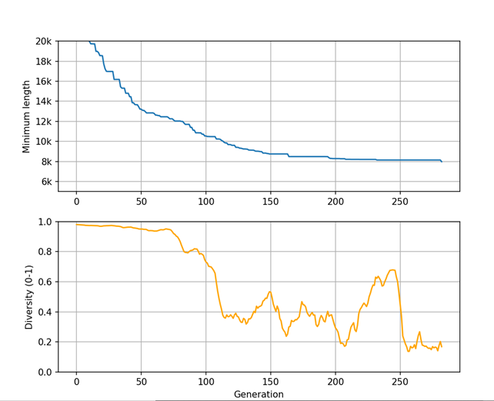
6. Evolution of Population Performance

Chart Analysis:
- Minimum Length (Upper Graph): Strong initial exploitation (rapid drop from 20,000 to 9,000 in the first 150 generations), then improvement slows.
- Population Diversity (Bottom Graph): Diversity decreases with convergence (exploitation), then increases with mutation, allowing for exploration.

7. Best Result Achieved
The genetic algorithm was run until it identified a solution with a total distance less than the constraint of 8000.
Best Total Route Length Found: 7973.76 units
Order of Places to Visit (after node 1 and before returning to node 1):
[48, 31, 44, 18, 40, 7, 8, 9, 42, 32, 50, 10, 51, 13, 12, 46, 25, 26, 27, 11, 24, 3, 5, 14, 4, 23, 47, 37, 39, 43, 33, 34, 35, 38, 36, 45, 15, 28, 29, 1, 6, 41, 19, 49, 22, 20, 16, 2, 17, 30, 21]

8. Conclusion
The Genetic Algorithm (GA) successfully solved the Traveling Salesman Problem for the berlin52.tsp instance, achieving a total distance of 7973.76 units, which is less than the limit of 8000. The order-based representation and the recombination and mutation operators for permutation problems were critical to the algorithm's effectiveness in balancing exploration and exploitation.

